LAB REPORT # 09


Submitted by:

Submitted by:

Name | Registration No.
Muhammad Abdullah | FA24-BSE-042

Submitted to: Raheel Ahmed
Course: Digital Logic Design (EEE240)
Dated: MAR 25, 2026.

DEPARTMENT OF COMPUTER SCIENCE
COMSATS UNIVERSITY ISLAMABAD,
ISLAMABAD CAMPUS
Lab Report 9: Design and Implementation of BCD to 7-Segment Decoder on Proteus
Introduction
7-segment displays are widely used in electronic devices to display numerical information. A BCD to 7-segment decoder converts a 4-bit binary input representing decimal digits (0-9) into signals that drive a 7-segment display.
Objectives
- Design a BCD to 7-segment decoder using logic gates.
- Simulate the design using Proteus software.
- Verify the correctness of the simulation results.
Truth Table:

BCD (DCBA) | a | b | c | d | e | f | g
0000 (0) | 1 | 1 | 1 | 1 | 1 | 1 | 0
0001 (1) | 0 | 1 | 1 | 0 | 0 | 0 | 0
0010 (2) | 1 | 1 | 0 | 1 | 1 | 0 | 1
0011 (3) | 1 | 1 | 1 | 1 | 0 | 0 | 1
0100 (4) | 0 | 1 | 1 | 0 | 0 | 1 | 1
0101 (5) | 1 | 0 | 1 | 1 | 0 | 1 | 1
0110 (6) | 1 | 0 | 1 | 1 | 1 | 1 | 1
0111 (7) | 1 | 1 | 1 | 0 | 0 | 0 | 0
1000 (8) | 1 | 1 | 1 | 1 | 1 | 1 | 1
1001 (9) | 1 | 1 | 1 | 1 | 0 | 1 | 1

Results:
Simulation Results
The simulation results in Proteus matched the expected output as per the truth table. Each BCD input correctly resulted in the corresponding 7-segment display output.
Observed Outputs:
- BCD input 0000 resulted in 1111110 on the 7-segment display.
- BCD input 0001 resulted in 0110000 on the 7-segment display.
- BCD input 0010 resulted in 1101101 on the 7-segment display.
- BCD input 0011 resulted in 1111001 on the 7-segment display.
- BCD input 0100 resulted in 0110011 on the 7-segment display.
- BCD input 0101 resulted in 1011011 on the 7-segment display.
- BCD input 0110 resulted in 1011111 on the 7-segment display.
- BCD input 0111 resulted in 1110000 on the 7-segment display.
- BCD input 1000 resulted in 1111111 on the 7-segment display.
- BCD input 1001 resulted in 1111011 on the 7-segment display.

Minterms and their Reduce Equations using kmap:
a(D,C,B,A) = Σm(0,2,3,5,6,7,8,9)
A'BD+A'C+AB'C'+B'C'D'
b(D,C,B,A) = Σm(0,1,2,3,4,7,8,9)
A'B'+A'C'D'+A'CD+B'C'
c(D,C,B,A) = Σm(0,1,3,4,5,6,7,8,9)
A'B+A'D+B'C'
d(D,C,B,A) = Σm(0,2,3,5,6,8,9)
A'B'C+A'BC'D+A'CD'+AB'C'+B'C'D'
e(D,C,B,A) = Σm(0,2,6,8)
A'CD'+B'C'D'
f(D,C,B,A) = Σm(0,4,5,6,8,9)
A'BC'+A'BD'+AB'C'
g(D,C,B,A) = Σm(2,3,4,5,6,8,9)
A'B'C+A'BC'+A'CD'+AB'C'
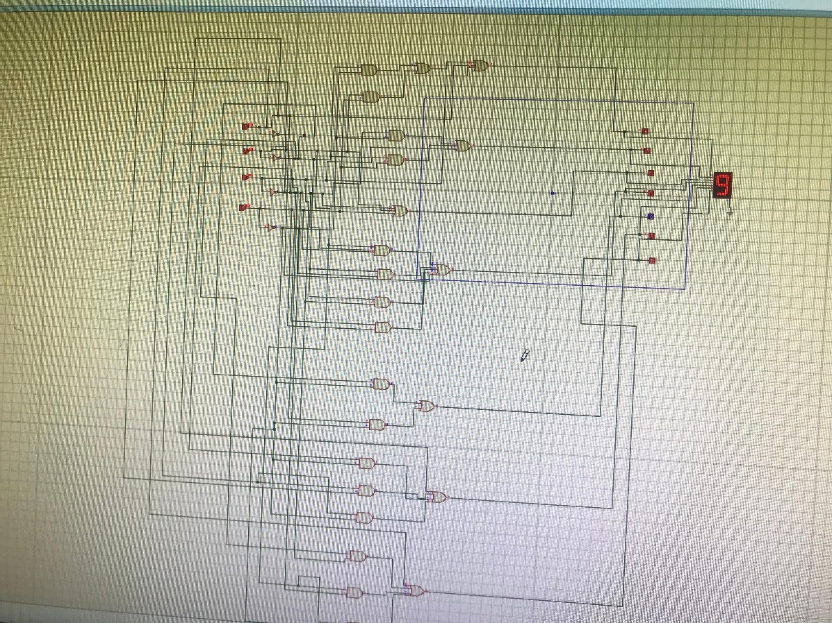

Discussion
The successful design and simulation of the BCD to 7-segment decoder in Proteus demonstrate the feasibility and effectiveness of using this software for digital logic design. The Proteus simulation confirmed the design's correctness and robustness. The observed outputs matched the expected results, validating the combinational logic implemented.
Conclusion
The BCD to 7-segment decoder was successfully designed and simulated using Proteus. The design met all specified requirements, and the 7-segment display outputs were accurate for all BCD inputs from 0 to 9. This lab exercise highlights the utility of Proteus in digital system design and simulation.

